STSSCIS806 Vocational science/ Wave physics I
Unit/Topic | Performance Criteria | Assess Event | Date | Time
Waves, sound and light | - to 3.5 | Project | /5/2013 | 1 day
Student Name | Teacher | Class | Total Mark
 | Ayman AlOmari | VEDC+ | /20
Marking Scheme
Category | Max.  Mark | Mark | Comment
1 | 4
2 | 4
3 | 4
5 | 4
Total | 20

Student signature:  I certify that the work presented is my own.  I acknowledge that I have received and understood feedback about this assessment. | Sign | Grade
 |  | /20
Student Comment:

Teacher comment:

Building a Periscope: Rubric

Getting a good mark is easy, just look at the criteria listed under the top mark of ‘4’ for each category. If your project meets all the requirements, then your mark will be quite high!
Category | 4 | 3 | 2 | 1 | Mark
- Does the periscope work? | The periscope easily reflects the laser onto the target | The periscope has the ability to reflect the laser onto the target | The periscope is complete, but unable to reflect laser onto target | Periscope is incomplete
- Written explanation | The explanation is neat and gives all details about what is happening | The explanation is present, but is not neat/complete | The explanation is incomplete and messy | Explanation missing or in the early stages of completion
- Overall neatness and care taken | The periscope is very well built, and all written/artwork is done well | The periscope is generally neat and well built, but some aspects could be improved | The periscope is complete, but not well built and much improvement could be made | The periscope is incomplete or very poorly built.
- Ability to work with a partner | Both partners gave equal input and effort into the project | Both partners gave input, but one did significantly more work | Very little input from one partner, the other did most of the work | One partner did nearly 100% of the work.
- Diagram of periscope on the attached sheet | The diagram is complete, neat and clearly shows the ‘ideal’ angles of reflections | More information is needed and/or more care is needed for neatness | A diagram is present with some information but elements are missing | Diagram is missing or only in the early stages of completion
Total/20

Part A:- Make A periscope
Introduction:
Although rays of light travel only in a straight line, they can be reflected so that images are brought to our view, which are normally outside our range of vision.
We cannot normally see around a corner or an open door. But if we hold a mirror at arm’s length and so adjust its angle that we can see into it, while at the same time it reflects a view from the other side of the corner or the open door, we have succeeded in seeing behind walls.
Submarines and tanks use periscopes. These are quite complicated affairs, but still use the same principle of reflecting the rays of light.

You will need: Cardboard A4 size or larger, two small mirrors, scissors, glue, tape, scissors, pencil and ruler.
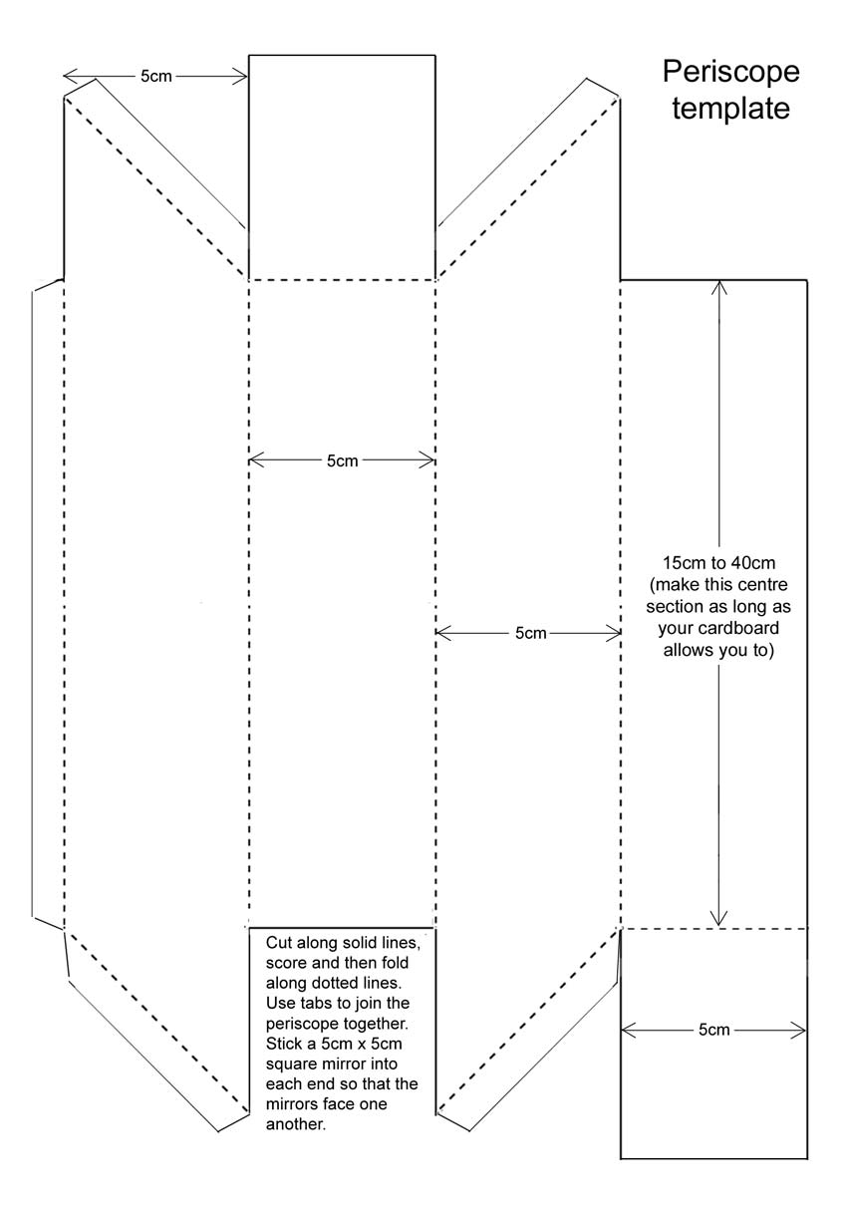
Procedures:-
- Carefully glue the attached template on your cardboard or draw it with a ruler.
  - Note:- It is important to check that all four sides of your periscope are 5cm across before you cut it if you are using 5 cm mirrors).
  - Note:- You can make the length of the periscope as long as your cardboard if you have a really big piece of card.
- Cut template out carefully along the solid lines. Don't cut the tabs off!
- Get sure to score along every dotted line.
- Fold carefully along all the scored dotted lines. (you can fold round the ruler or a sharp edge)
- Use tape or strong glue to stick the periscope together using the tabs.
- Stick one mirror into each end, facing each other. Strong glue or double-sided tape work best.
- Now try to see over something taller than you, or hold the periscope sideways and look round a corner. If you put your finger under one end and look into the other end, your finger will look as long as the periscope!
- Draw the light rays on the diagram to show how the image of the tree is formed.

